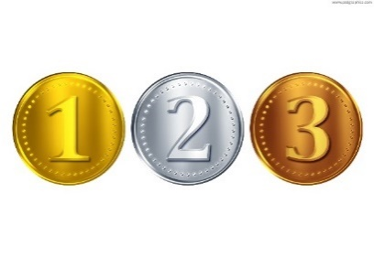SILVER LEVEL TASKS – LEVEL 2

.

# Task – Bubble Sort

Take the rules that we discussed previously and develop the bubble sort with a list entered by the user that is separated by commas.

## Save

Save your file as **bubblesort.py**

# Task – Merge Sort

Take the rules that we discussed previously and develop the merge sort with a list entered by the user that is separated by commas.

## Save

Save your file as **mergesort.py**

# Task – Insertion Sort

Take the rules that we discussed previously and develop the insertion sort with a list entered by the user that is separated by commas.

## Save

Save your file as **insertsort.py**

# Task – 2D Array

Write a program which takes 2 digits, X,Y as input and generates a 2-dimensional array. The element value in the i-th row and j-th column of the array should be i*j.

Note: i=0,1.., X-1; j=0,1,¡­Y-1.

Example

Suppose the following inputs are given to the program:

3,5

Then, the output of the program should be:

[[0, 0, 0, 0, 0], [0, 1, 2, 3, 4], [0, 2, 4, 6, 8]]

Hints:

* Note: In case of input data being supplied to the question, it should be assumed to be a console input in a comma-separated form.

# Task – File read

Write a program to read and print an entire text file

## Functions to use

**def**

**print**

**open**

# Task – File append and display

Write a program to append text to a file and display it

## Function to use

**def**

**from**

**open**

**with**

**print**